**Name :** Zong Fan

**Part-1 : Linear Interpolation**

1. Insert your linear interpolated test image(hope.jpg) here:

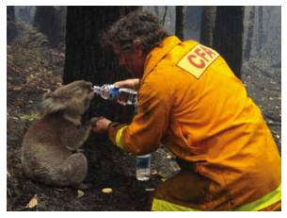

1. Display the map/plot of all the 3 training images here:

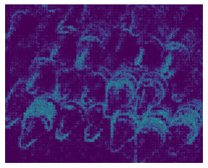

Pixel difference map of crayon

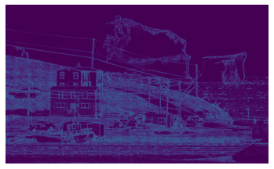

Pixel difference map of iceberg

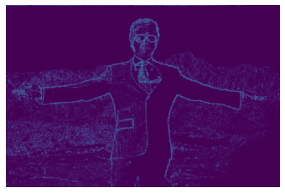

Pixel difference map of Tony

1. Post close-up of any artifacts you came across.

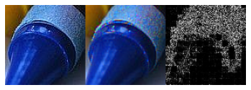

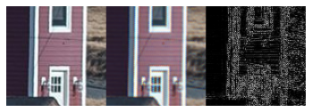

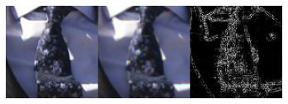

Left to right: original image, resolution image, pixel difference map

1. Average_per_pixel error and Max_pixel_error for each of 3 training images :

|  |  |  |
| --- | --- | --- |
| Image | Average_per_pixel_error | Max_pixel_error |
| Crayons | 43.5 | 498 |
| Tony | 15.1 | 533 |
| Iceberg | 44.3 | 651 |

**Part-2 : Freeman Method**

1. Insert your Freeman Method test image(hope.jpg) here:

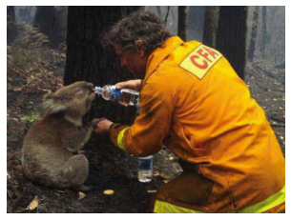

1. Display the map/plot of all the 3 training images here:

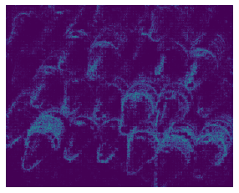

Pixel difference map of crayon

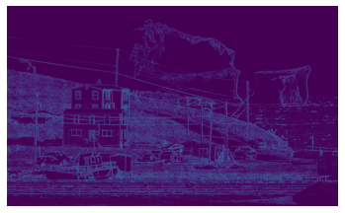

Pixel difference map of iceberg

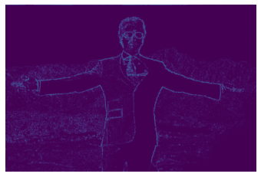

Pixel difference map of Tony

1. Post close-up of any artifacts you came across.

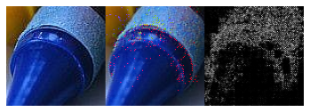

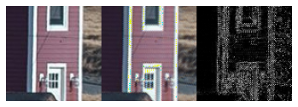

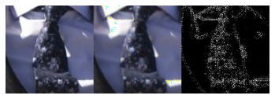

Left to right: original image, resolution image, pixel difference map

1. Average_per_pixel error and Max_pixel_error for each of 3 training images :

|  |  |  |
| --- | --- | --- |
| Image | Average_per_pixel_error | Max_pixel_error |
| Crayons | 39.9 | 702 |
| Tony | 11.9 | 678 |
| Iceberg | 37.3 | 739 |

**Part-3 : Images of your choice**

1. Post 2 images of your choice here and the corresponding error maps of your outputs with the Freeman method.

Towel:

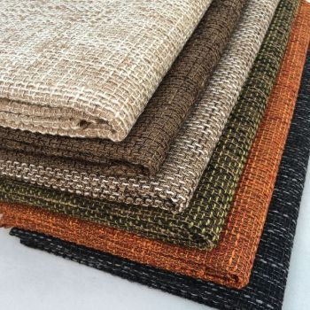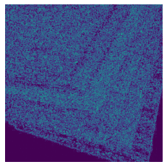

Mean error: 156.5

Grass land:

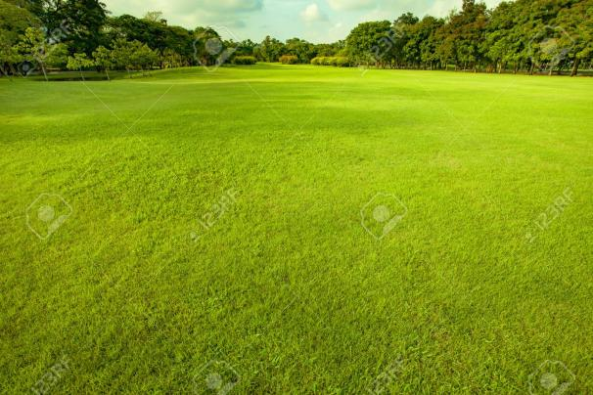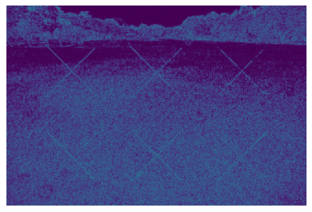

Mean error: 126.4

1. Any image that breaks the method and why do you think so?

If the color of neighboring pixels change sharply, the basic interpolation fail to retrieve the real color information from neighboring pixels. Especially the Freeman method depends on values of green channels for modification, it means that the Freeman’s modification may fail to improve the demosaicing quality if the green values are not recovered realistically.

**Part-4 : Bonus**

Post any extra credit details/images/references used here.

The original bilinear interpolation method doesn’t consider existing color information when trying to restore other colors on the pixel. Like previous examples, if the color or luminance changes shapely, the bilinear interpolation cannot handle these pixels correctly. So one way to alleviate such limitation is to add existing color information as estimated luminance information. Another way is to increase the size of the kernel to consider more pixels during estimations. This paper proposed a method to improve the demosaicing performance with previous two modifications. (Link: <http://web.stanford.edu/class/ee367/reading/Demosaicing_ICASSP04.pdf>)

The demosaicing grass land image has max pixel error reduced from 747 to 498 and mean pixel error form 126 to 107.

